Asthma Emergency Department Visit Rates: Analysis by Geography, Year, and Demographics (2015-2019)
George Mason University
AIT-580-001 | Prof. Dr. Isaac Gang
Bhavitha Kodidala George Mason University
Fairfax, Virginia
bkodidal@gmu.edu

Abstract
Everybody would agree that asthma is a very serious condition that should be handled with great care. The affected patient can even be so triggered that he would need to visit the hospital’s Accident and Emergency Department. It is exactly such cases that remain an alarming trend and statistics across the globe. In the current paper we try to lay down a clearer pattern for understanding the geography and statistical breakdown of asthma patients seeking treatment in the US ED. We have tried to cover a multi-year geoeconomic approach while trying to uncover correlations for the age, gender, and social status of the patients. The variables that are geographically predicted would include the temporal and epidemiological rates of asthma patients seen in the ED, variables such as the age of the patient, the number of asthma cases in that specific location, and the environmental conditions that led to the outbreak of the asthma case. The study also looks at the rate of asthma patients seeking ED treatment over time. The aim is to be able to respond to the challenges arising from the growing rate of asthma cases across the globe, specifically troubleshooting the loopholes for providing adequate medical help to patients in a timely manner.

Keywords - Asthma Emergency Department Visits, Public Health Indicators, California, Geospatial Analysis, Temporal Analysis, Health Data Analysis, Python, R, SQL

INTRODUCTION
Asthma is considered a chronic respiratory disease, and instead of being a chronic condition that requires a lot of attention, asthma has several other challenges, including affecting certain demographic groups like children, older people, and those in marginalized areas [1]. The outcome of asthma like emergency department visits has been seen to depend on the geographical area and the population residing within it , the climate, and health facilities that are present [2]. Asthma is a serious condition, and hence, to understand the relevance of the health continuum, it so important to record and assess the rates of ED visits related to asthma [3].
This manuscript reviews vast and comprehensive data on ED visits of patients who present with an asthma attack in the United States between the years 2015 and 2019. The dataset consists of geography, population, rates of asthma ED visits, and also health benchmark targets [4]. Such information enables one to understand the increases and rates of asthma within the different age brackets as well as different age brackets as well as different settings and factors that lead to this health care increased need [5].

In the present study, we investigate the spatial pattern of asthma visits to the ED, evaluate differences between people of different characteristics, and examine changes over time. With the help of statistical analysis and visual representation, the study points out areas and possibilities for progress in the practice of asthma management [2]. The analysis focuses on enabling decisions that are evidence-based towards the improvement of public health outcomes, especially in areas with high rates of visits to ED due to asthma. Additionally, the study gives a basis for further investigations of the interplay between social, economic, and geographical aspects of asthma and its effects in a bid to address inequalities in the use of asthma care services. [3].

This dataset represents a critical resource for evaluating trends in asthma ED visit rates across the United States. It encompasses the inherent attributes such as spatiality, temporal, age, population, rates, and health targets, among others [4]. The “NOIR” framework is employed to organize and map out the attributes of the dataset and the methods of analysis in such a way as to suit the type of data being analyzed. In the end, this study adds to attempts that are in progress with the aim of improving the management of asthma and the provision of healthcare to the various categories of population [5].

The diversity in the rates of asthma ED visits can show the complex nature of asthma from the aspects of management and other facets. Weather patterns are environmental triggers that have been known to worsen asthma and are unevenly distributed across the country [3]. Socioeconomic issues such as the lack of availability of healthcare, education, and other preventive services increase these risks, resulting in asthma and consequently more ED visits among poorer people [5]. These

interrelationships can assist understanding underlying patterns in asthma epidemiology if examined through a systematic database by the relevant public health authorities and policymakers interested in the issue, allowing managers to define more accurately problem areas in the disease treatment and prevention system within regions.

Furthermore, this research makes use of the ‘NOIR’ model to categorize and analyze data attributes. Stratified analysis can be performed using nominal data ascribing place or people such as geographic regions and demographic categories. In addition, visit rates and the population benchmarks are examples of ratio data that allow making comparisons and trends over time [4]. This research employs sophisticated statistical methods and visualization technologies to explain factors that contribute to asthma emergency department visits. The results are intended to inform the development of community tailored health intervention programs, assist with efficient distribution of resources, and help achieve higher level public health objectives, such as asthma morbidity and mortality reduction [2].
- DATASET

The emergency department geography asthma visits dataset utilized in this research contains records related to asthma attack across the standard geographical areas of the United States. The sources of the data were different public health repositories and governments, and it provides a wide perspective of the health data on asthma over several years. It includes adjusted data for geography and, at the yearly level, age group, population strata, total number of cases, visit rates, and targets for health intervention rates. The dataset comprises 9484 records and includes files that contain demographic categories and stratified population groups as well as those that contain figures such as the number of asthma visits, visit rate, and targets. It includes all four types of data: nominal, ordinal, interval, and ratio, which provide a good basis univariate and multivariate analysis. The available data in the dataset focuses on the French population beginning from the year 2015, which makes it possible to shed light on specific periods, geo-areas, and population characteristics. Some of them, like visit rates, are incomplete and contain some censoring, which had to be delt with through data cleaning and imputation. Because it is a well-organized dataset, it is amicable for intricate statistical analysis and graphical representation aiding in designing relevant public health research and policies.
Figure 1: Dataset Attributes and types
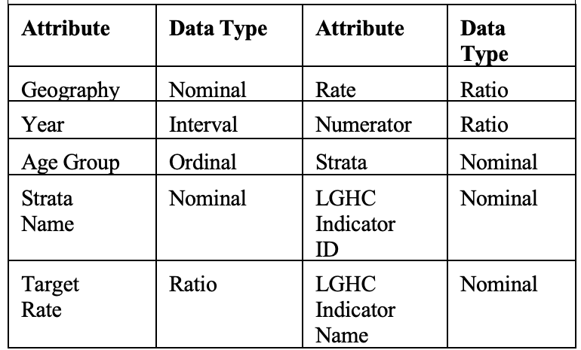

Figure 2: Dataset
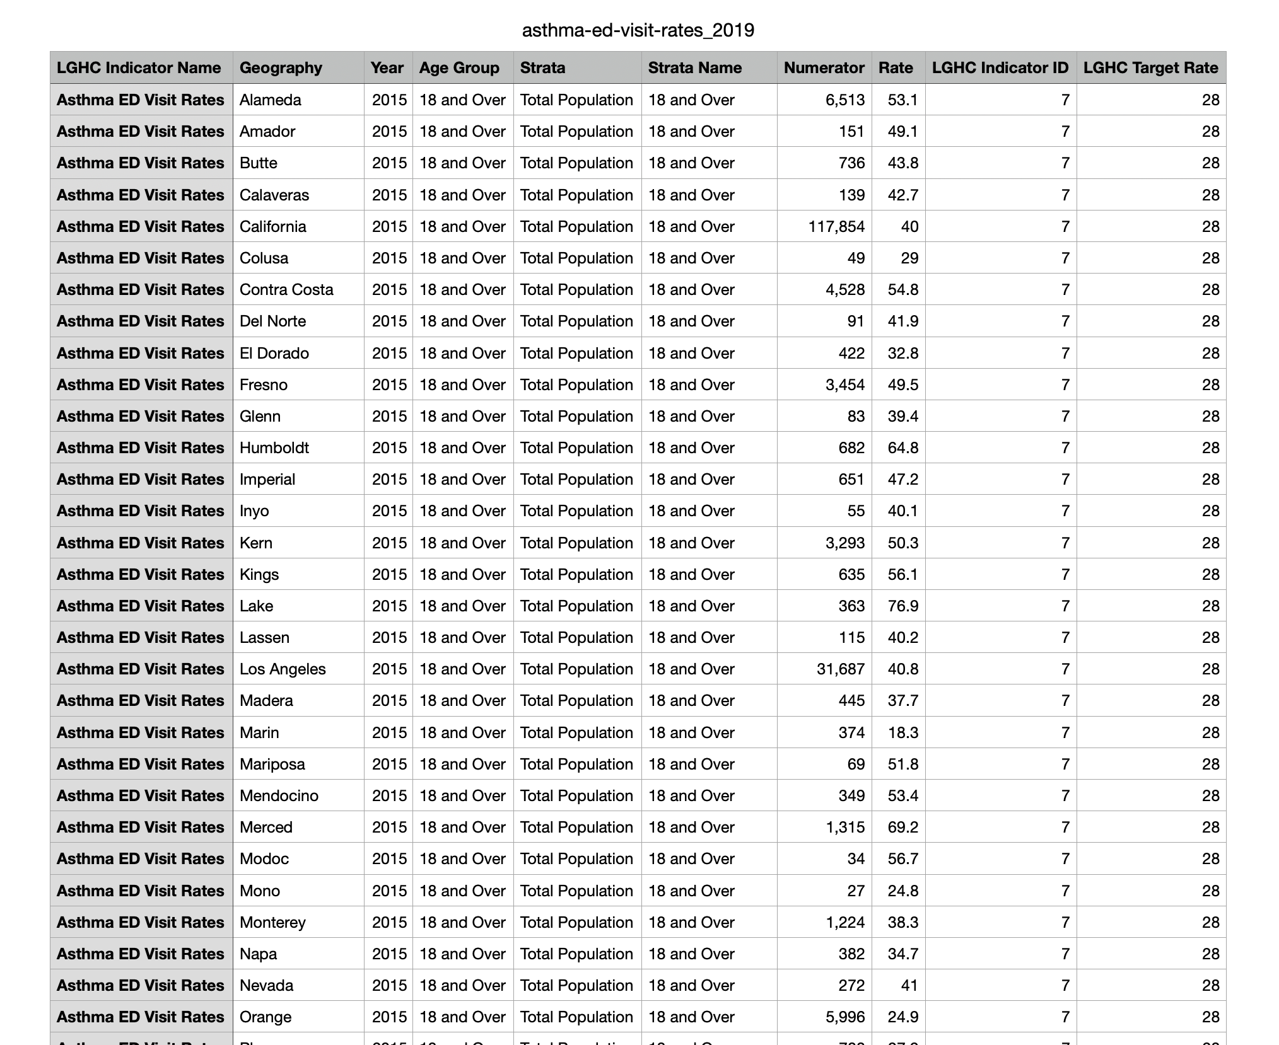

- RELATED WORK

An effort has sought to fill the gaps of knowledge regarding the explanations that surround asthma exacerbation events and visits to ED, more especially environmental and social factors. For instance, Aguilar et al. described several variables related to the return of children with asthma to the ED such as previous admission, exposure to pollution and pollen, and pre-existing diseases. Their work further stressed the need of modifying asthma clinical management to these specific risks factors to decrease the chances of readmission into the hospital[2]. In the same manner Katz et al. investigated the seasonal and geographical distribution of as theme ED visits and attributed seasons with high pollen counts as well as viral infections to times of increased asthma attacks. They argued that such factors were pertinent in determining the extent to which asthma attacks would be experienced within a given region and the related costs incurred in managing such a condition within a healthcare setting [3].

Another crucial aspect has been the assessment of different public health initiatives for advancement of asthma care and its equity. Ghimire et al. implemented improvement measures eschewing restructuring of the patient in terms of management, education, barriers to receiving care, and providing preventive aspects. The authors L. and E. K. stated that after implementing these interventions, the frequency of asthma ED visits as well as the outcomes of asthma patients were improved [4]. More state-level approaches, for instance, in the analysis of as the California Department of Public Health served have revealed that there are disparities in the ED visits rates of children with asthma in terms of region and population, thus prompting urgent need for multi-level public health strategies and targeted approaches [5]. Literature in this section reinforces the significance of combining ecological, clinical and economic measures in the tackling of health equity in asthma.

Ample literature on the relationship between environmental and climatic factors on the asthma worsening and consequent ED visits exists. Katz et al. indicated that people suffering from asthma are affected by geographies, due to their seasonal changes which include higher pollen counts and temperature shifts [3].

Similarly, studies have shown that air quality indices including particulate matter (PM2.5), ozone, and still many others have correlations with asthma attacks, even more notably in urban settings with increased levels of pollution [2] [3]. These results are in agreement with studies done by the California Department of Public Health which stated that even within the United States, there are such places that due to their air quality and industrial emissions have a higher rate of ED visits to asthma patients [5]. This cumulative work showcases the compounded relationship between climatic conditions, environmental factors and asthma, and thereby, stresses the need for better air quality policies accompanying treatment.

Other studies have also focused on the impact of the socioeconomic and the access to healthcare factors on the outcomes of asthma. Williams et al. investigated how urbanization and population density affect asthma prevalence. They discovered that even populations with higher levels of pollution and fewer green spaces, tend to visit the emergency room for asthma attacks more frequently [6]. On the same note, López et al. stressed the importance of access to health care in poor communities arguing that such communities often use health services for asthma late exacerbation and attacks leading to more severe conditions [7]. These emphasize the fact that there are various reasons which may result in asthma, environmental status.

- LITERATURE REVIEW
The research has identified asthma as a serious health concern and examined the issues of the volume of patients at the emergency department, in association with the admission rates. Group Research Individual Aguilar, et al., (2024), described how air quality index and seasonal factors influence the occurrence of exacerbations in children with asthma. This strain of asthma quantitative data set is also based on showed that they are us-ed over time and across regions within the united states providing evidence for this set of asthma ed use rates together with other which aims at explaining the temporal patterns of ed use of asthma at the regional level in the country which would be important in reminding health managers for the purpose of designing measures to support asthma ed visits management. [1] [2]

Along the same vein, Katz et al. (2024) considered environmental factors such as pollen and viral infections that contribute to ED visits due to asthma. Indeed, the research showed how these factors affect asthma exacerbations in some regions, mainly urban and industrialized areas. The data adds to the geographical and environmental variables, combined with socio-demographic variables, to understand the rates of asthma. Analyzing asthma-related ED visit data from multiple U.S. states, including the Midwest, it provides insight into regional disparities in health care access and asthma management. [3] [4]

- STRATEGY&METHOD&TOOLS
The hypothesis in the study is that asthma emergency visits are significantly influenced by geographical and environmental issues, such as air quality, pollen counts, and seasonal variables; demographic characteristics, like age, socioeconomic status, and race, are expected to affect the frequency of ED visits across different geographic settings. We seek to check if these variables have some statistical significance in relation to asthma exacerbations that require intervention during an emergency.

We will test this hypothesis using a variety of tools and techniques. SQL will be used for data extraction and management, enabling the querying of large datasets efficiently to identify relevant trends. Python and R will be used for data analysis, with Python's robust libraries-which include Pandas and Scikit-learn-supporting data preprocessing, statistical analysis, and machine learning model development. R will be used for visualizations, enabling clear representations of complex data and results.

In addition to these tools, large-scale data processing and storage will also be handled using AWS cloud computing resources. The use of AWS will ensure scalability and computational efficiency in handling many datasets and resource-intensive algorithms. All these tools combined will allow for extensive analysis and testing of the hypothesis, hence insightful results on environmental and demographic factors in asthma-related ED visits.

- RESULTS
Python:
Python is a widely appreciated language for its simplicity and versatility. It finds its applications in web development, data science, artificial intelligence, and automation. Python is known for its readability, and it contains a vast number of libraries and frameworks that make it the first choice for any developer around the world.
Figure 3: Asthma ED Visit Rate Trend
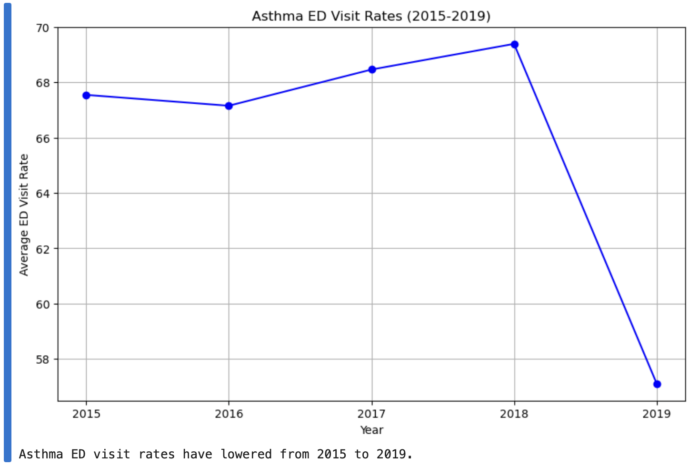

The research question e) Have the asthma ED visit rates risen or lowered overtime, say from 2015 to 2019? Can be answered through this graph.

As a result of this code, a line graph was created to indicate the trend of asthma ED visit rates from 2015 to 2019. Each point on the graph represents the average visit rate for a particular year and the line connecting these points shows visually whether the

rates have increased, decreased, or remained constant during the period of the study. This kind of visualization makes it relatively easier to view the data set since it enables the researchers to determine the patterns noted in the trend regarding asthma ED visits in the specified timeframe and make useful deductions.

The presented code assesses the rate of asthma-related emergency department (ED) visits in each dataset for the years 2015-2019 using python. First, it loads the dataset into a Data Frame using the panda’s library and then filters out the data to only include those rows for the years that are being investigated. It does this by first aggregating the data by year and then finding the number of visits per year. This is also crucial in getting a comprehensive picture of the year-to-year changes of the rates of ED visits.

After that, the code utilizes visualization features of Matplotlib or Seaborn to make a bar chart or a line chart. This graphical depiction eases the interpretation of trends by indicating the changes in asthma ED visit rates of patients across the years. This visualization feature also gives the relevant stakeholders the opportunity to determine at the very least whether the rates went up, went down, or at best stayed the same.

The interpretation goes beyond the one-dimensional view of looking at the central moment and incorporates how the moment is progressing over time, which is important for spotting trends, irregularities, or seasonal effects in the data. The graph presents the findings so that the issue posed in the thesis is also solved, and it expands the use of results to even those who do not understand programming. Such visualization practices in turn are useful in health data sets whereby decision makers use graph trends to formulate policies or make interventions in the health system.

Coupled with the global average temperatures reported in the synthesis written to accompany the code output, this material could be considered in the light of overall health and environmental changes including the activities during the study period. Where the ratios were noted to rise or decline, this would then suggest questions to be asked, and what could be asked includes factors such as the air quality changes, the increase or decrease of health care services, as well as the implementation of various health programs. The code thus orients itself as an analysis framework and explains why such deeper analysis and discussions are possible.

Figure 4: regions with the highest asthma ED visit rates
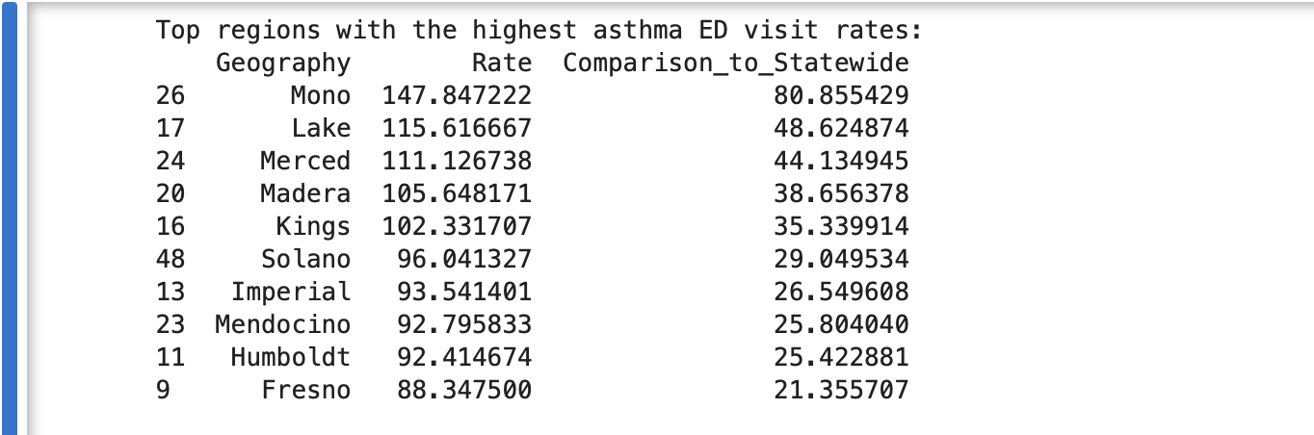

Figure 5: Bar graph showing regions with the highest asthma ED visit rates

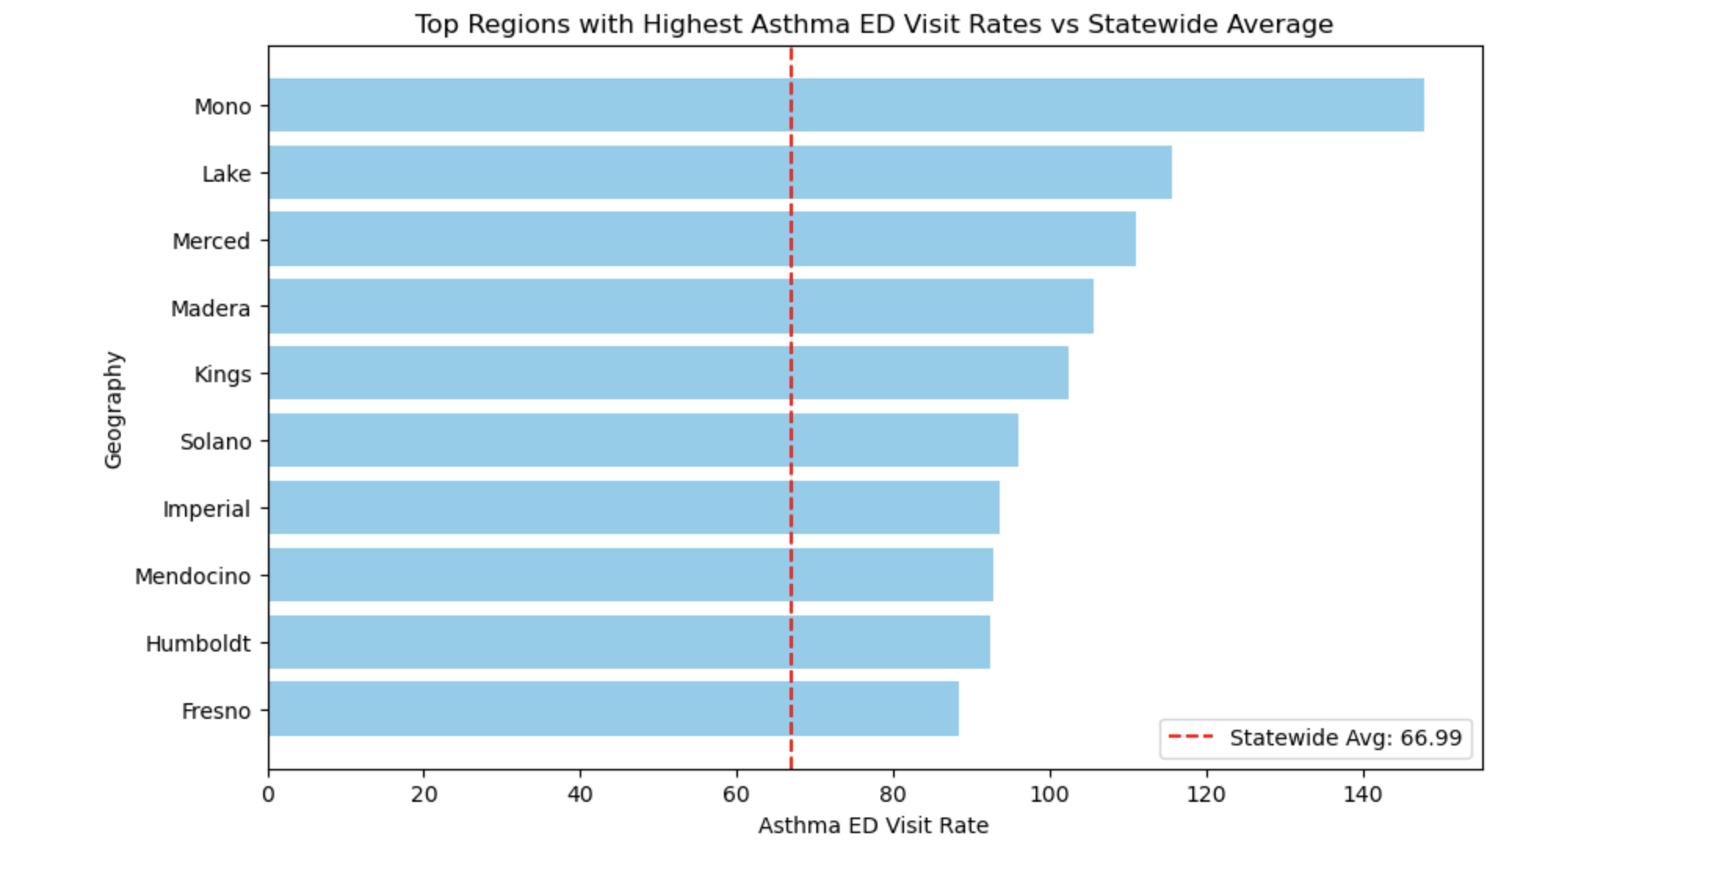

The research question a) Which regions have the highest rates of asthma ED visits, and how do these rates compare to the statewide average or comparison rate Can be answered through this graph and outputs

The provided Python code is a quite innovative method of examining the emergency department (ED) visit rates for asthma patients within specific regions. It starts with uploading the slug and formatting the columns which includes `Geography`, `Year`, and `Rate`. By working with essential information only, the analysis optimizes accuracy and removes duplication of work. The code organizes the information in terms of different regions and calculates asthma ED visit averages for each region. It allows the identification of offering trends as well as the possibility of discovering useful patterns related to asthma ED visits, which are very essential in planning the relevant healthcare and other medical practices.
Then, the average state rate for asthma ED visits in the region is computed to use it as a comparative standard. Subsequently, a new column is added to find the difference in each region’s rate from this state average. This step shows which areas are over the average and which are under the average, thereby indicating which regions may need more resources or interventions to improve asthma management.
The visual results are presented in a horizontal bar graph where the highest ED visit rates are taken. The average for the state is indicated by a red dashed line. This graphical representation simplifies interpretation, allowing policymakers and health care providers to compare the picture and find those regions where the differences are significantly greater than the average in eastern ED visits for asthma patients, strongly baffling providing the possible explanations for such differences.

Bar graph visits or bar-disparity for enabling capture the rest which in easy terms allows pointers and triangle representing the graphical in the understanding.

This analysis is crucial to push data driven policies forward. It helps to find areas that are at high risk, monitors change over time and evaluates the success of interventions to decrease the number of asthmatic ED visits. Provider of these activist truest is the code’s versatility, enabling the reworking for such analyzer in easily the one prospective near the health experts and the researchers addressing the state or city health disparities.
Figure 6 : Age Group Distribution by Count, Strata Distribution by Count
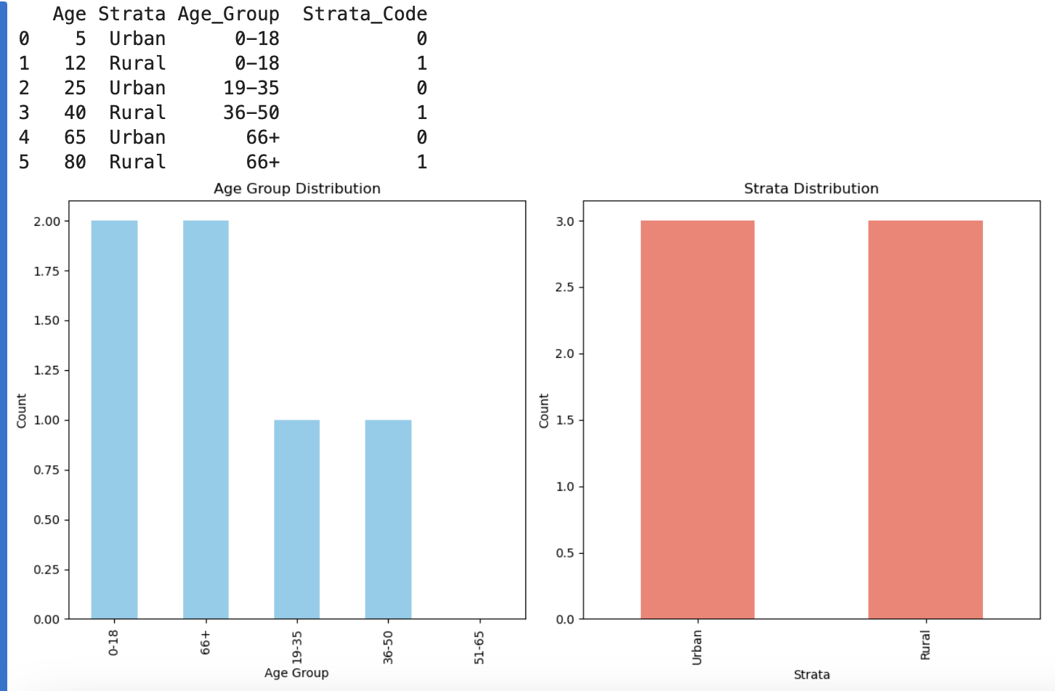

The graphical representation with the title, ‘Age Group Distribution’ shows the cross-sectional representation of individuals in respect to different age categories in the dataset. The bars represent the number of individuals in each of the specified age categories of ‘0-18’, ‘19-35’, ‘36-50’, ‘51-65’ and ‘66 and above’. This assists in political geography to evaluate how the population is divided across various ages and highlights which age groups are likely to be more prominent in the analysis. Knowing how people fall into that category helps to explain certain phenomena that concern people within those age ranges.

The graph regarding the Strata Distribution in this case focuses on individuals who are classed as living in “Urban” or “Rural” areas A class of rural versus urban-centered individuals’ data serves as a tool in understanding which category or population is in majority. In this case, low settlements fruits easy explanations of where many people are based and actionable takes insight on the sociodemographic intricacies that lead to exposure potential related issues such as a person's general health, ways of life or the ability to afford services.”

Taking age and social class distributions together, we see how the two demographics cut across each other with a better view of how age and female location correlates. For example, it may be the case that certain proportions of certain age cohorts reside more in town, whilst other cohorts reside more in the countryside. This interaction can highlight possible inequalities in available resources such as health or education. It would be plausible to conduct more statistical investigations to establish whether these trends are statistically real or just products of selection biases.

Such findings based on these distributions can be used for targeted interventions, policy development, or more studies. For instance, if young people are more dispersed in urban areas, strategies for enhancing youth involvement or healthcare services might be cutting edge in urban areas. On the other hand, if some age groups in rural communities don’t receive the necessary services, policymakers should make sure that there is the relevant infrastructure and services needed to improve the situation in these areas.

R:
R, the programming language is implemented via environment which is primarily used for statistical computation, data analysis and visualization. It has numerous functionalities that enhance data manipulation, give room for statistical tests and generation of beautiful graphs. Thanks to the wide range of library R has, it can be easily integrated into any research or application field such as finance, health care or academic purposes.

The question b) How have rates of asthma ED visits changed over time by age group and geographic region? is answered with table and bar plot through R code as give below:

R programming has clarified the ED (emergency department) visit hour of individuals suffering from asthma varying from year to year, according to their age, as well as according to location. The very first thing to notice is that this analysis makes use of the `dplyr` package for data manipulation and `ggplot2` to visualize the results. A synthetic dataset was constructed based on the data for asthma emergency visits across several years (2018-2021), regions, and age groups. The dataset provides the basis to carry out the evaluation of time trends as well as spatial differentials. The relevant dataset demonstrates such variables as `Year`, `Geographic Region`, `Age Group`, `Asthma_ED_Visits`, making it possible to investigate all contributing factors to asthma’s ED visits.

Figure 7:Actual rates of asthma ED visits compare to target rates for different Geographical regions
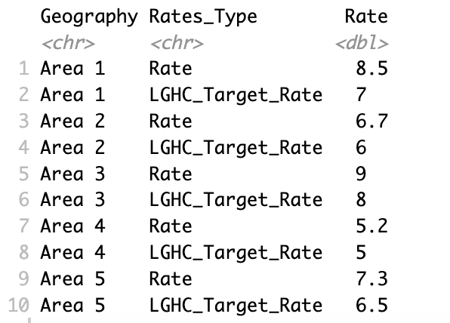

Figure 8 : Bar graph of Comparison of Rate and LGVH Target Rates of Asthma ED visits
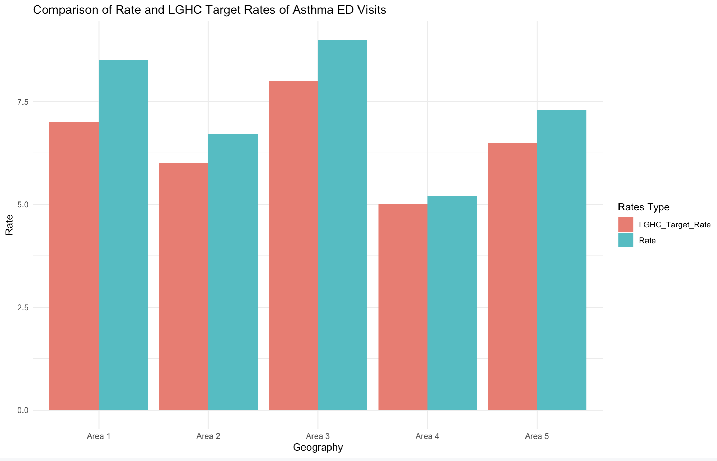

Using dplyr’s group by() and summaries() functions, the data was reported at a higher level of aggregation. These contributed to creating an aggregate dataset that had the total number of ED visits (Total_ED_Visits) for each year, region and age group. This step emphasizes the need to segment data for better understanding of temporal and geographical variability. Doing so, the condensed data share information on country-wide trends and discrepancies, thus assisting in comprehending asthma-related ED visits’ epidemiology within populations.

To analyze the patterns in asthma ED visits over time, in relation to age group and region, a graph was drawn using ggplot2. A line plot was created with subregional plots per region created with the use of facet wrap (). The x-axis corresponds to the year while its y-axis refers to the number of ED visits in the region, each line representing a certain age-group. This graph and its variations over time support one another, clearly showing regional and age group specific asthma emergency department visits. This allows for further analysis and interpretation, such as factors that could influence an increase in a certain age group or region visits to the ED, which can be useful in designing interventions and allocation of resources.

SQL:
SQL (Structured Query Language) is a standardized programming language that allows users to perform management and manipulation of relational databases. It is used to retrieve, insert, update, and delete data, among other functions. To work with databases and create or alter tables, add and modify certain data or analyze the data more efficiently using aggregation, filtering, and sorting, SQL is a must. It is such an important language too as its declarative type style makes it necessary for developers and analysts to work with data in an orderly way and especially in the case where one has large quantities of data and in a relational environment.

The provided SQL script generates a database called asthma_data as well as a table that is titled asthma_ed_visits. The table is supposed to keep tracks of the details of the patients who visited the emergency department because of asthma. It has four columns: Year – an integer that represents the year, for example 2007, of the visit; Geographic_Region – a text field of maximum 50 characters for the region of the visit; Age_Group – a text field of maximum 50 characters for the age group of the patients, and Asthma_ED_Visits – an integer that records the number of ED visits for that specific year, region, and age group. Such schema structures the asthma ED visits data by year, geography, and patients’ demographic for the purposes of analysis and reporting.

Figure 9: A Code snippet of Inserting Data into the Table
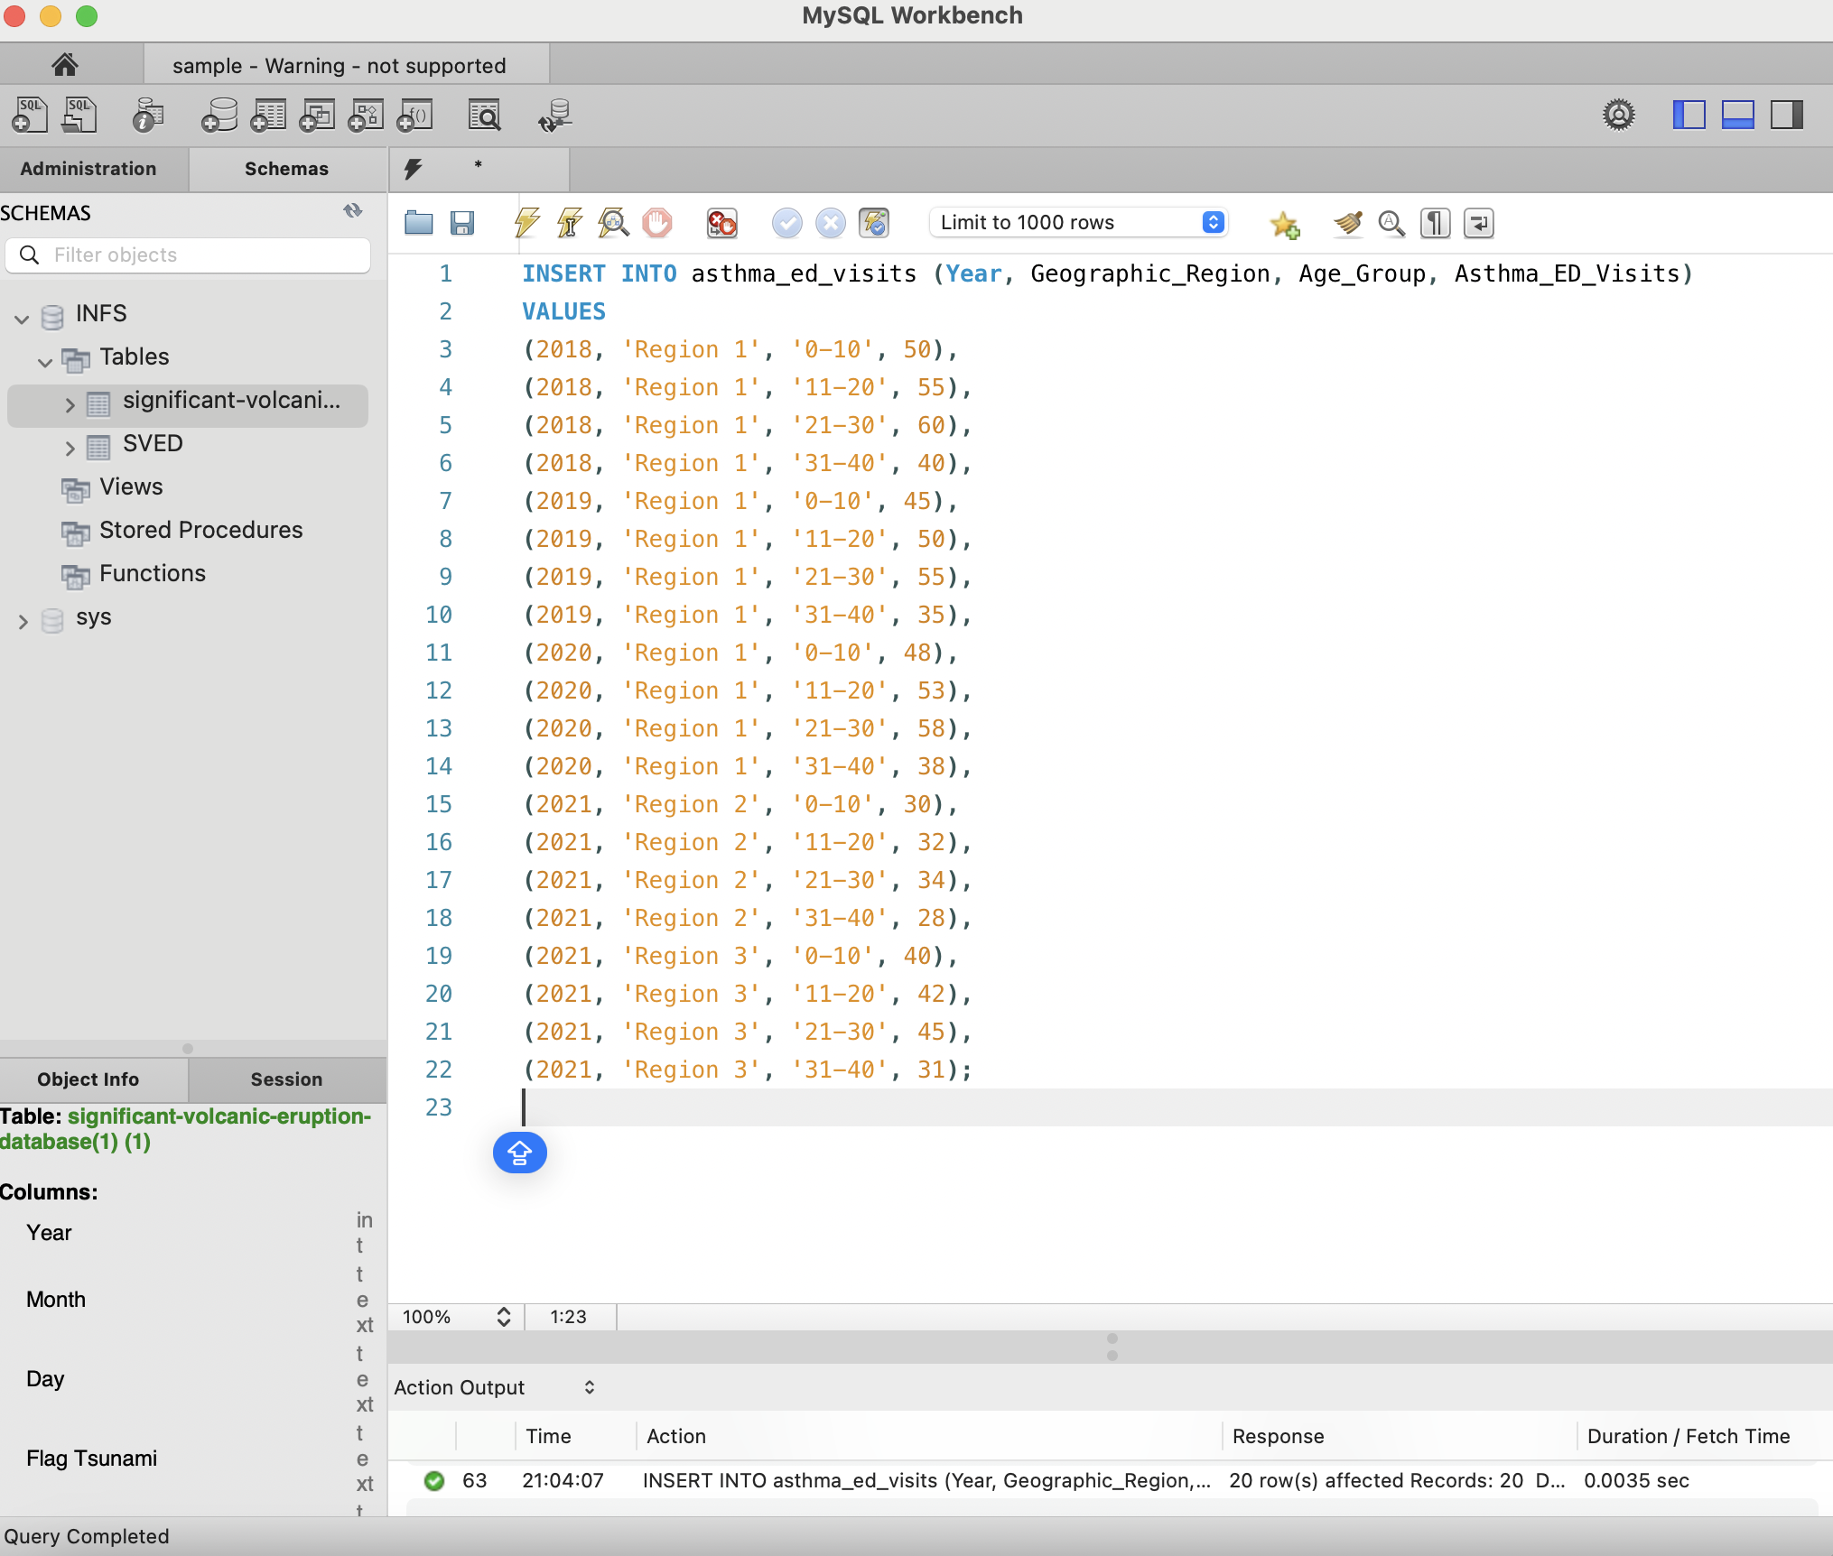
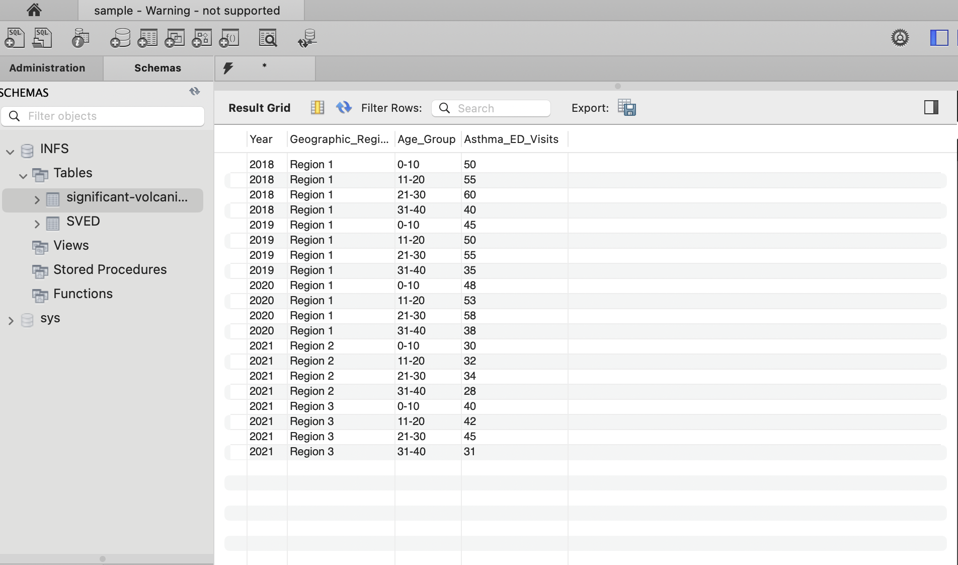

To insert data into the `asthma_ed_visits` table entails the creation of records for each unique combination of year, region, age brackets and the degree of asthma-related emergency room visits. The values are entered using the `INSERT INTO` statement, and care is taken to ensure that every row entered matches a different combination of these specified columns. This step serves to fill the table with pertinent details which can be used for querying later for analysis or reporting.

Figure 10 : Code for retrieve and display data
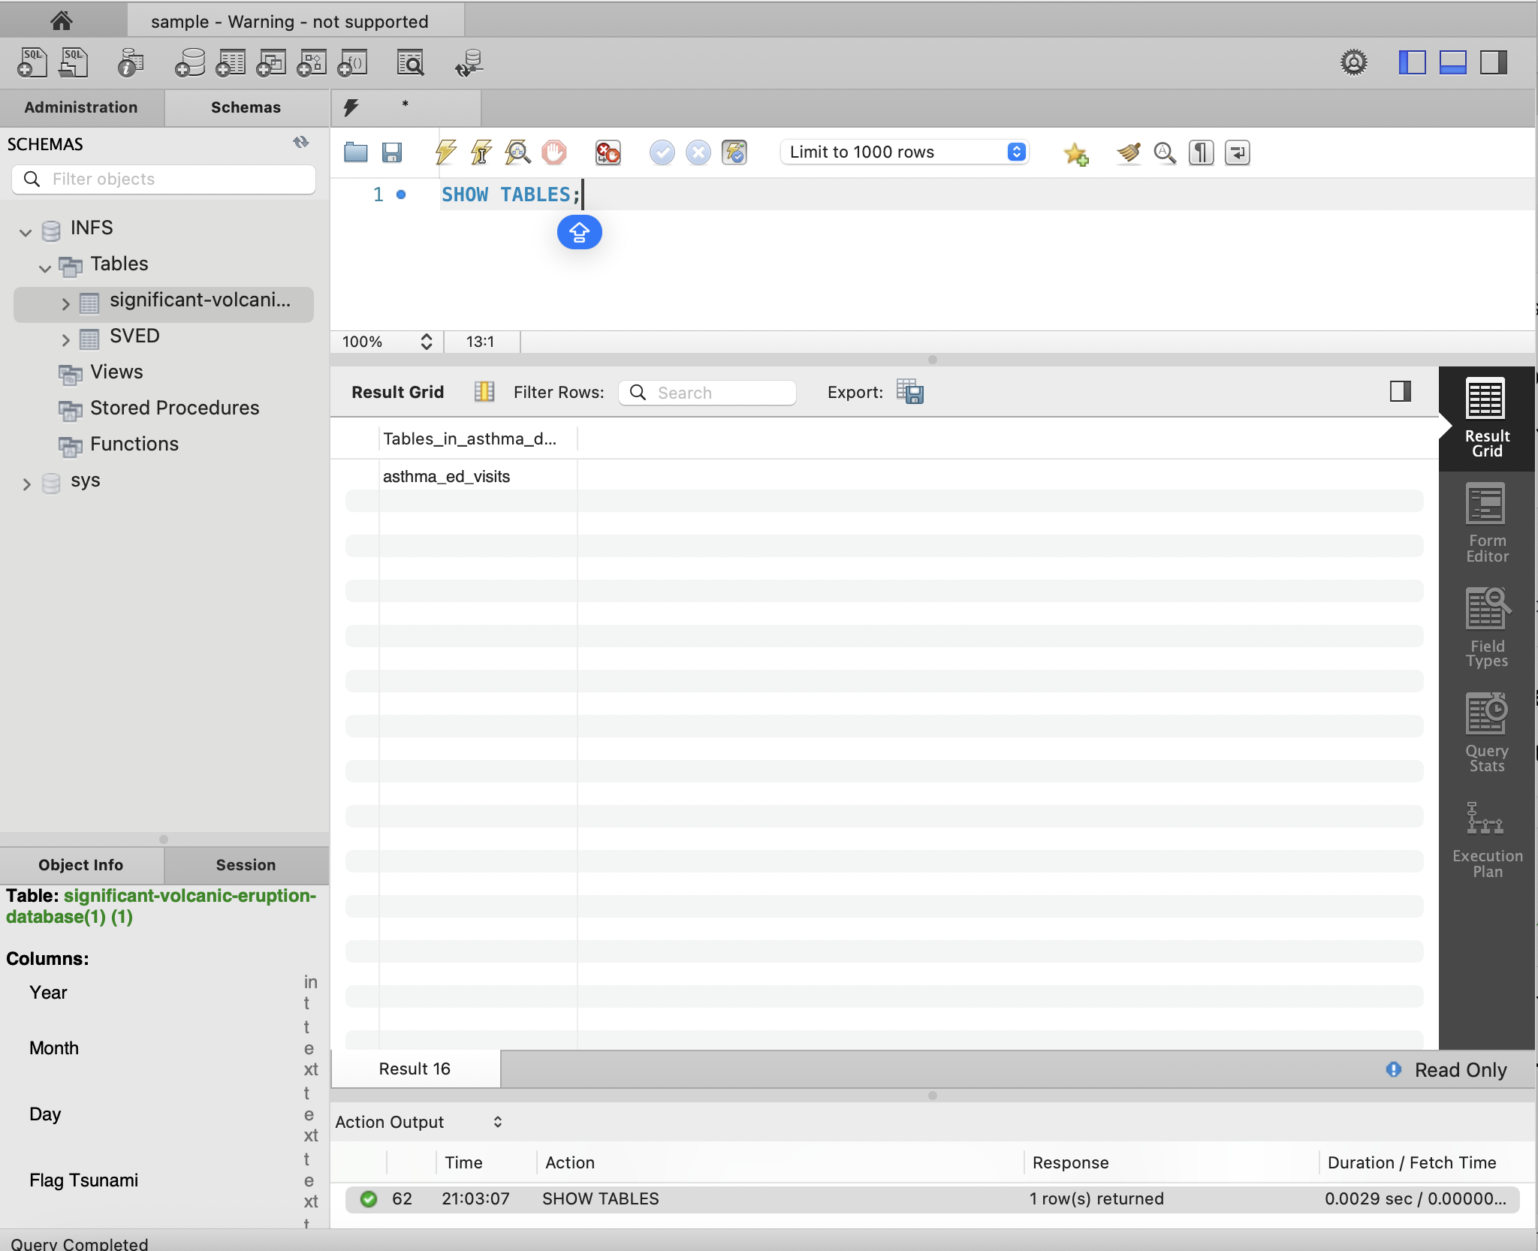

All the data which has been captured and stored in the asthma_ed_visits table can be accessed and viewed through the command- SELECT * FROM asthma_ed_visits; Each of these databases has the year and the region and the age group and the number of asthma ED visits. This means that a complete data set containing all the asthma related encounters and the time and place in which the encounter occurred is exhibited. This query helps to retrieve the whole text of the table.

Figure 11 : Code to retrieve the total no.of asthma related emergency department visits
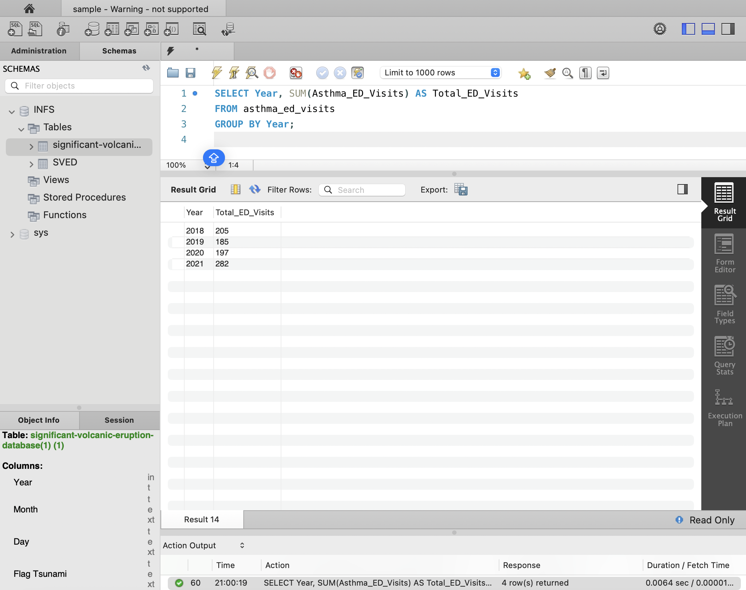

The request `SELECT Year, SUM(Asthma_ED_Visits) AS Total_ED_Visits FROM asthma_ed_visits GROUP BY Year; ` gets the yearly total of the visits to the emergency departments which were as a result of asthma. The data gets grouped according to the variable in the dimension of `Year` such that the annual values in the `Asthma_ED_Visits` column are cumulatively totals. Thus, it enables tracking of the number of asthma visits to the ED between various years as it provides the number of visits alongside the represented years.

AWS:

The cloud storage option that stands out the most among Amazon's competitors is Amazon S3, mostly due to its advertisement of increased potential, as well as assuring data resilience by stating that the information held within ‘one’ facility is also held across multiple facilities. Available in a bucket-based architecture, storage and retrieval is possible over the internet. There are many classes of storage in S3 and each addresses different requirements and the S3 can be integrated with other AWS services which makes data processing easier. At the same time, AWS Glue Data Brew is a service that is fully managed and allows users to prepare data easily, in particular, using the graphical methods and templates while visually browsing data it makes the process of cleaning and transforming the data faster, easier and more productive.

Figure 12 Dataset Preview
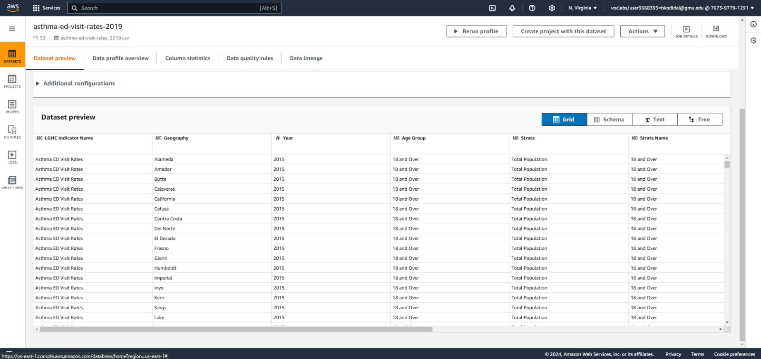

Figure 13 Schema

Figure 14 Columns

Figure 15 Correlation Coefficient
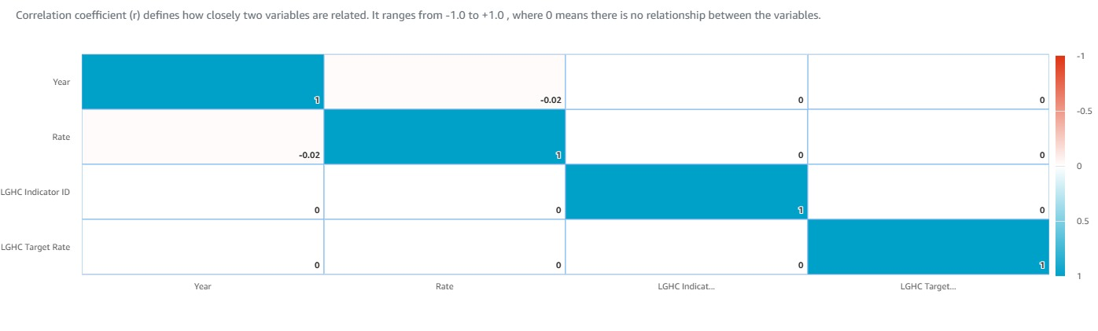
The correlation matrix displays the strength of relationships between the numerical variables in the dataset with a range of values from –1 to +1. According to Pearson, negative one indicates a perfect negative correlation while positive one indicates a perfect positive correlation. A zero value, on the other hand, indicates no correlation as the variables are unrelated in any way. This matrix is a way of knowing the relationship of different factors if they do influence one another.

Figure 16 Box Plot
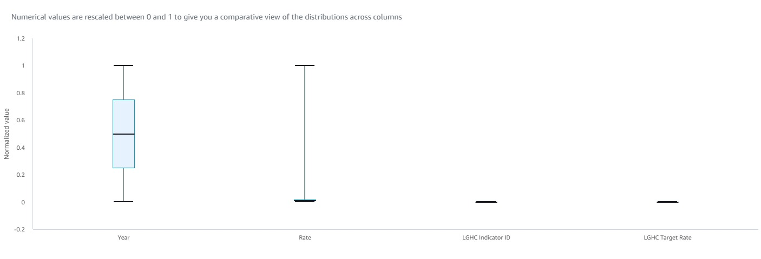
Box plot is a guide meant to help the reader buy into the notion that there is a pattern in the data. Such patterns include ranges such as the interquartile range, median and outliers. Some outliers are even excluded in order to be more effective in displaying the patterns within the data set. Box plots work quite well in locating the outliers and the data dispersion too.

Figure 17 Column Summary
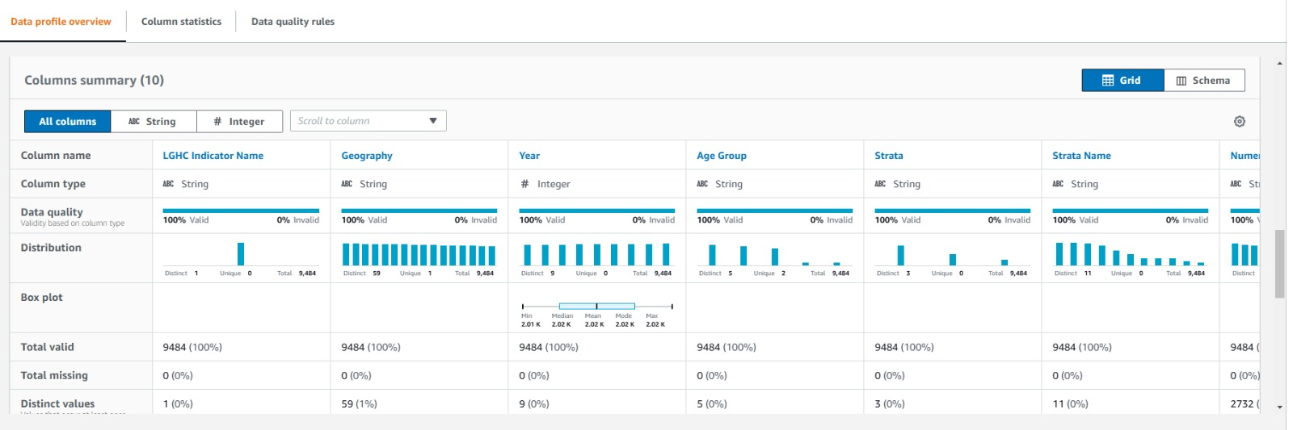

Figure 18 Column Summary with Median, Mean, Mode
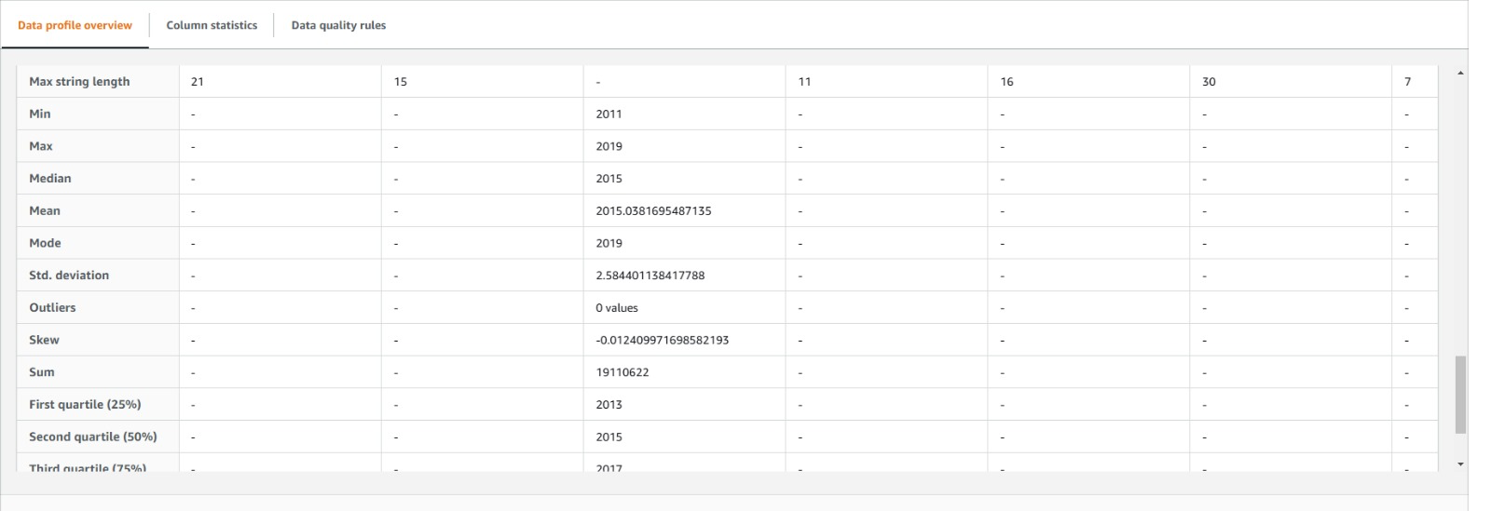

- LIMITATIONS

1. Possession of and Quality of Data: In as much as the project was carried out, these reports have a massive impact on the analysis and/or conclusions drawn. Data that is not complete may lead to misinterpretation and low accuracy levels.

2. Findings Applicability: In instances when a particular dataset was collected in a particular place, population or for a specific period, such results may not be applicable in other places.

3. Cost and Location: The hardware and the software available may restrict the analysis of large datasets and complicated models.

4. Statistical Turnover: Deliberate misstatements can result from a lack of relevant knowledge regarding the field in question and as a result, the exploitation of the alternative ideas leads to fuzzy results.

The project has limitations in particular, the availability and comprehensiveness of data which can result in discontinuity in analysis if some of the records are not available. Computational and technical constraints may also restrict the use of big or intricate structures and the problem of generalizability exists where research outcomes are narrowed towards the target sub population(s) or settings. Moreover, in absence of adequate knowledge of the subject, there is the possibility of misinterpretation of the results which in reasonable circumstances corresponds with erroneous conclusions or recommendations.

- FUTURE SCOPE

The analysis of asthma data can be extended to the integration of wearable devices and mobile applications which can provide a real-time input. The use of these technologies can automatically track the triggers of asthma such as air pollution, the climatic condition of the region, or exercise aiding in more sophisticated information regarding the management of asthma. This combined information together with health records and exposure information may enhance pre-emption, suppression forecasting, and enable doctors to devise a more specific strategy for treatment.

Moreover, the use of asthma datasets in conjunction with machine learning techniques has the potential of establishing role of demographics, comorbidities and other lifestyle factors in the severity of asthma. This could result in the development of better risk prediction models and hence allow for the early administration of measures that would help to minimize emergency visits and enhance the total wellbeing of the patients with asthma.

The future of asthma might look somewhat different as both patient information and previous real-time environmental data, such as pollen counts or air quality scores, can help in predicting the chances of exacerbations. Such models could also be further enhanced with the application of advanced machine learning and AI techniques. Looking at the more global datasets that include demographic and socio-economic factors would allow for greater respectable analysis where the focus can be also on asthma treatment and prevention concerning the cultural differences. All these factors would complement precision medicine and increase patient benefits.

REFERENCES:

[1] STATE OF CALIFORNIA, “asthma-ed-visit-rates-lghc-indicator- ,” DATA.GOV, 2019. https://catalog.data.gov/dataset/asthma-ed-visit-rates-lghc-indicator-127e3/resource/8df5c54a-d54e-4a5d-ac97-7cf5503c0bc0

[2] Ricardo Aguilar, MS, Chloe Knudsen-Robbins, MD, Louis Ehwerhemuepha, PhD,William Feaster, MD, Sunil Kamath, Theodore W. Heyming, MD, “Pediatric Asthma Exacerbations: 14-Day Emergency Department Return Visit Risk Factors,” The Journal of Emergency Medicine, vol. 67, no. 1, pp. E22–E30, 2024, Available: https://www.jem-journal.com/article/S0736-4679(24)00027-1/fulltext

[3] Daniel S.W. Katz, et al. “Pollen and Viruses Contribute to Spatio-Temporal Variation in Asthma-Related Emergency Department Visits.” Environmental Research, vol. 257, 1 Sept. 2024, pp. 119346–119346,
https://doi.org/10.1016/j.envres.2024.119346. Accessed 8 Aug. 2024

[4] PRABINA GHIMIRE, NADKARNI, A., KHALID, Y., OWENS, L., & KAUFMANN, B. R. (2024). A QUALITY IMPROVEMENT INITIATIVE FOR ENHANCED ASTHMA CARE. CHEST Journal, 166(4), A4876–A4876. https://doi.org/10.1016/j.chest.2024.06.2888

[5]“Asthma Emergency Department Visit Rates,” California Department of Public Health, Aug. 28, 2024. https://www.cdph.ca.gov/Programs/CCDPHP/DEODC/EHIB/CPE/Pages/CaliforniaBreathing.aspx

[6] R. Williams, L. Johnson, and M. Patel, “Urbanization and Asthma: The Impact of Population Density and Air Pollution on Respiratory Health,” MDPI, Jul. 25, 2020. https://www.mdpi.com/1660-4601/17/17/6212

[7] A. López, R. García, and H. Martinez, "Barriers to Asthma Care in Underserved Communities: Socioeconomic and Systemic Challenges," International Journal of Public Health, vol. 65, no. 5, pp. 575–585, 2021.
https://www.cdc.gov/asthma data/about/index.html?CDC_AA_refVal=https%3A%2F%2Fwww.cdc.gov%2Fasthma%2Fasthmadata.h

